West Bend Public Library Strategic Plan 2026-2031

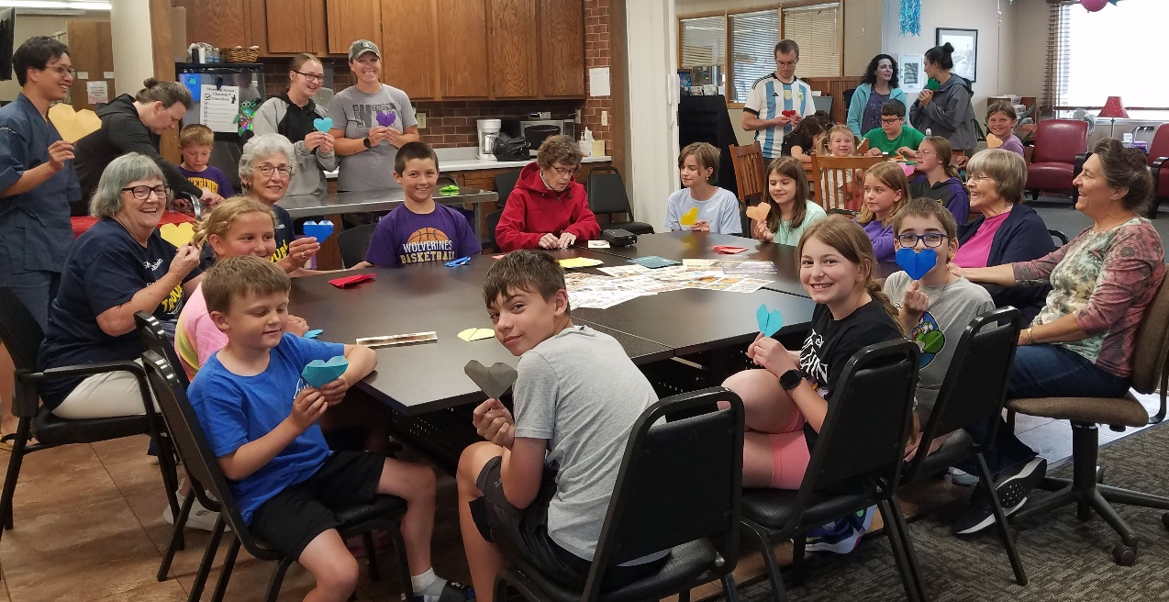

“We need to remember across generations that there is as much to learn as there is to teach.” Gloria Steinem

Approved by the West Bend Public Library Board of Trustees—July 2025

Community Data Analysis
West Bend was established in 1856 and incorporated on January 31, 1884. Nestled among the fertile fields of Iowa’s countryside the town is located in Palo Alto and Kossuth counties in north central Iowa just southwest of a sharp westward turn (bend) in the Des Moines River.
There are, according to Census data, 775 predominately white English speaking citizens in West Bend. About 18% of the population is Hispanic and a few Native Americans call West Bend home. The minority population has doubled in the last 10 years. Almost 40% of the community is aged 60 or older. The children of West Bend are fortunate to be able to attend school at all grade levels in the community. This is becoming rarer in Iowa as school districts continue to consolidate. Approximately 20% of the population is school age.
A large number and wide variety of businesses help the local economy thrive. Unemployment is equal to the state average and the median income is a bit above the state average as well. Citizens have access to information in a variety of formats including local and regional newspapers, cable access channels and Internet providers. There is a daycare center, assisted living and care center, as well as a medical clinic in West Bend. West Bend is also home to many service organizations, civic groups and churches. The citizens take pride in the community’s recreational facilities, culture of volunteerism, strong family ties and long standing traditions, among other things.
West Bend is also home of the Grotto of the Redemption, known as the largest man-made grotto in the world. The Grotto of the Redemption has been placed on the National Register of Historical Places and contains the largest collection of precious stones and gems found anywhere in one location. This attraction brings people from all over the world to visit our community.
Data to complete the strategic plan was compiled from the State Data Center of Iowa and evaluated by the board of trustees to create the goals that follow.

Library
The West Bend Public Library was built in 1966. An addition in 1977 brought the building up to its current 3,024 square feet. The building is in adequate condition with a recent roof replacement after a hail storm, exterior insulation and siding upgrades and a digital sign update. The building is in compliance with all codes and ADA standards. The library sits on the main street of the business district so the location is excellent. Parking is good and there is adequate meeting room space.
Six employees keep the doors of the library open 41 hours each week with evening and Saturday hours. The library provides books, magazines, audio and visual materials, visual magnifying equipment, puzzles, puppets and more to its 898 card holders. The library also provides online resources such as; LIBBY eBook and audiobook downloads, Transparent Languages and digital archives of the West Bend Journal. The library has copy and fax services, 8 community access computers, as well as programs for Summer Reading, Story Hour and outreach services to the school and homebound residents.
The library staff is pleased to provide a nontraditional library environment that offers a place to gather and share ideas, yet sets aside time for quiet reading and reflection. The children’s summer reading program is a point of pride for the library staff. The fact that the library is accredited at Tier 3, the highest level possible by the State Library of Iowa, has created confidence in our staff to provide excellent service to our community. The staff appreciates the support received from the city and county governments, community, and Friends of the Library organization.

Staff
Lisa Riesenberg, Library Director Melissa Zaugg, Children’s Librarian
Amber Adamson, Library Clerk Jennica Ruppert, Library Clerk
Adriana Adamson, Library Clerk Haley Wirtz, Custodial Aide

Trustees
Cory Thilges- President
Doug Miller Stephanie Veon Isabell Grimm Lisa Blair

West Bend Public Library

Mission Statement
  - Our mission is to be the center of information and discovery in the community. We connect people, information and ideas to promote lifelong learning, literacy development, and community involvement.

Service Responses
  - Public Access to Facilities: Both Physical and Virtual
- People will have access to the library and digital world with no unnecessary restrictions or fees to ensure that everyone can take advantage of ever changing technology and resources.
  - Satisfy Curiosity: Lifelong Learning
- People will have the resources they need to explore topics of personal interest and continue to learn throughout their lives.
  - Visit a Comfortable Place: Physical and Virtual Spaces
- People will have a safe and welcoming physical place to meet and interact with others or to sit quietly and read. They will have open and accessible virtual spaces that support social networking.

Goals
Goal #1: People of all ages will have a place to learn something new
- Create a schedule of ongoing programs and evaluate annually
  - Determine what programs to offer on a continuing basis by annually surveying people
  - Offer programs at various times and locations to provide better accessibility to our community and use survey results to determine the best time to offer each program
  - Use resources such as Project Outcome to evaluate a programs actual impact on those who attend
- Develop bi-lingual programs, due to population growth which has doubled in the last 10 years, by 2027
  - Determine what programs for bi-lingual patrons to offer by using surveys and conversations
  - Create a conversations program to encourage practice of English and Spanish between native speakers
  - Staff will develop bi-lingual story time to include parents to nurture the family reading and speaking skills.
  - Staff will develop promotional materials for social media and flyers in Spanish of library services and programs
- Develop additional teen programs by 2028
  - Staff will attend workshops and webinars to learn how to promote and excite the teens. This goal includes doubling the number of programs offered to 10 or more per year. Possible programs include book to movie programs, book clubs etc.

Goals #2: People will feel welcome and comfortable while at the library
- Provide charging stations, chairs or tables and additional outlets for use by visitors who bring their own devices by 2027
  - Research options for charging stations and requirements for furniture that have adaptors built in
  - Discuss options with an electrician
  - Obtain funding for necessary updates
- Research options to provide a “teen friendly” area within the library by 2028
  - Discuss space options and floor plan ideas with staff and teens
  - Obtain funding and furniture for the area
- Refurbish restroom to be more accessible for patrons with disabilities by 2030
  - Evaluate measurements and assessments, obtain estimates and funding of any recommended changes
- Determine if electronic doors are necessary for patrons with disabilities to access the library more freely by 2029
  - Survey community members with disabilities of any accessibility concerns using the library.
  - Obtain estimates and funding to make requested changes.

Evaluation Plan
The West Bend Public Library Board will evaluate progress of the stated goals annually at the June board meeting. The West Bend Public Library Board will determine whether unmet goals or objectives are still valid and relevant to the library’s mission as well as whether new goals or objectives should be added to meet additional community needs.

