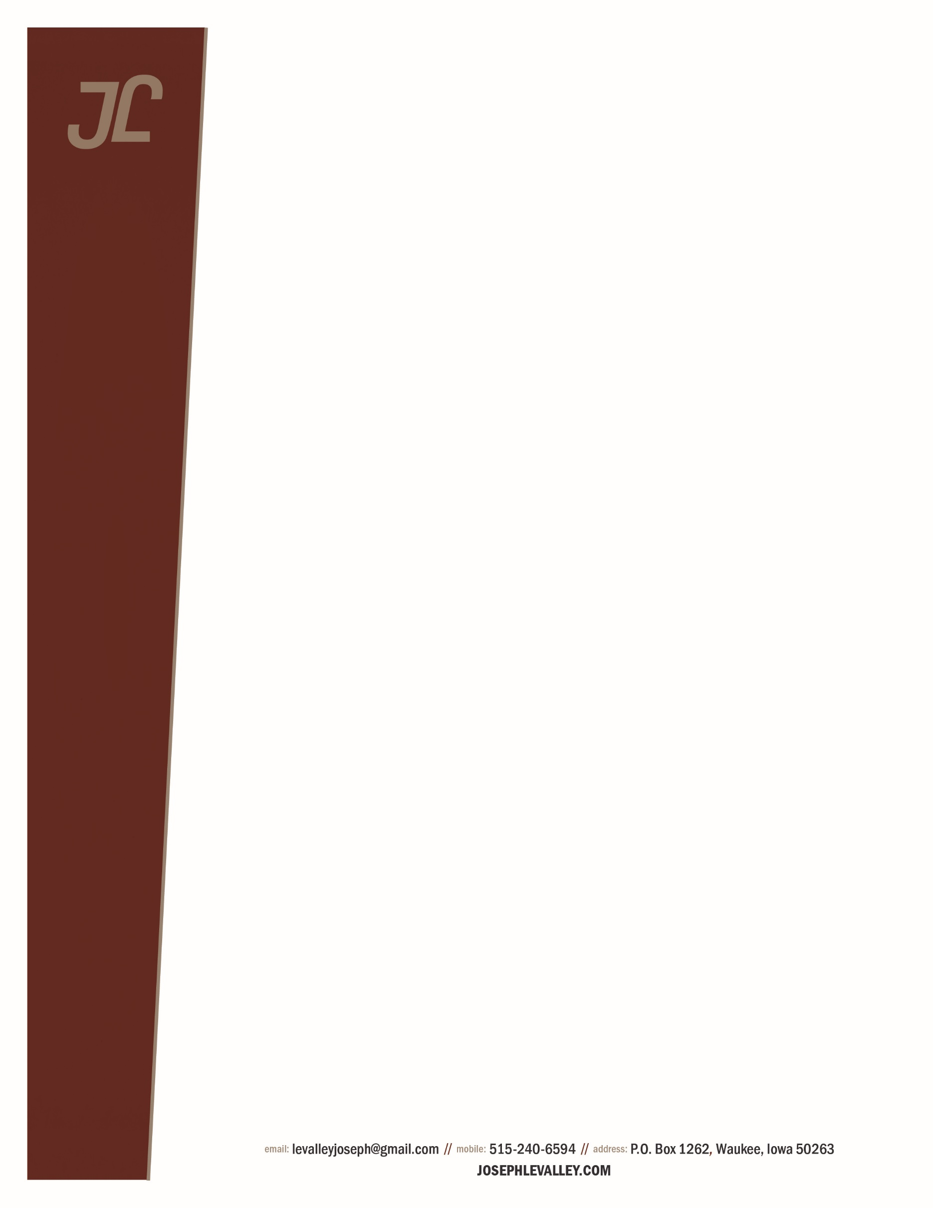Author bio– Joseph LeValley

January 2024

Joseph LeValley is the author of a series of award-winning mystery/thriller novels. Featuring a young newspaper reporter based in Iowa, the six published novels have won a dozen awards and honors from competitions in the U.S. and Canada. The most recent, *Three Weeks in Winter* was named the Best Mystery of 2023 by Maincrest Media, and Best Mystery/Crime of 2023 by the Global Literary Awards.

Prior to becoming an author, Joe was a reporter-photographer for Iowa newspapers for seven years, covering crime and criminal justice, and writing a variety of other news and feature stories. Subsequently, he worked as an executive in communications and business development for a large healthcare system for more than 30 years. He and his team won four national awards for communications excellence.

Joe also is a musician and composer. In 2016, he was inducted into the Iowa Rock 'n Roll Hall of Fame.

A lifelong Iowan, Joe has a BA in Journalism from Drake University and a Master of Business Administration Degree from the University of Iowa. He and his wife Jane have six children and live in Dallas County, Iowa.

To learn more, visit his website: [josephlevalley.com](http://www.josephlevalley.com); and follow him on Facebook and Twitter @josephlevalley.

The books:

*Burying the Lede*, 2018

*Cry from an Unknown Grave*, 2020

*The Third Side of Murder*, 2021

*Performing Murder*, 2021

*The Sophocles Rule*, 2023

*Three Weeks in Winter*, 2023