**Homeschool Resources**

Start Here

<https://educateiowa.gov/data-and-reporting/data-reporting/certified-enrollment/nonpublic-schools-certified-enrollment>

<https://www.homeschoolfacts.com/state-laws/iowa-homeschool-state-laws.html>

If you are new to homeschooling in Iowa, you should familiarize yourself with the laws. The Iowa Department of Non-Public Education can get you started with all of the information you need with regards to legal requirements.

You can also find:

Frequently Asked Questions

Testing Information

Student Driving Information

Curriculum and Online Education Information

[**Iowa State Board of Education**](http://www.google.com/url?q=http%3A%2F%2Fstateboard.ncpublicschools.gov%2Flegal-affairs%2Fresources-1%2Fhome-instruction&sa=D&sntz=1&usg=AFQjCNGTwMjbOOwoHSdyQFfnQkzuzcTRBA)

The Iowa State Board of Education can provide you a brief legal history of home education as well as keep you up-to-date on current legal requirements in Iowa statutes. <https://educateiowa.gov/iowa-state-board-education>

[**Iowa for Home Education**](http://www.google.com/url?q=http%3A%2F%2Fwww.nche.com%2F&sa=D&sntz=1&usg=AFQjCNF97cr82cQb54F1QOhMxxMoMkrD4w)

Iowa state wide support group AEA, <http://www.iowaaea.org/> strives to protect the freedom to educate children at home, to provide encouragement and support to families choosing home education for their children, and to promote home education as an excellent educational alternative.

[**Homeschool Alliance**](http://www.google.com/url?q=http%3A%2F%2Fwww.ha-nc.org%2F&sa=D&sntz=1&usg=AFQjCNEnWhupuz4cDe9I3OwNH9PYQEBazw)

The Homeschool Alliance of Iowa NICH is a grassroots network of independent homeschooling families who embrace a myriad of approaches to education, spirituality and lifestyle. You can not only find information regarding legal requirements and bills that may affect homeschoolers, but also information about self-advocacy to make your voice heard regarding existing and possible future homeschooling laws. <https://homeschooliowa.org/>

NICH also hosts the Love to Learn homeschooling conference that includes a variety of homeschool and education experts.

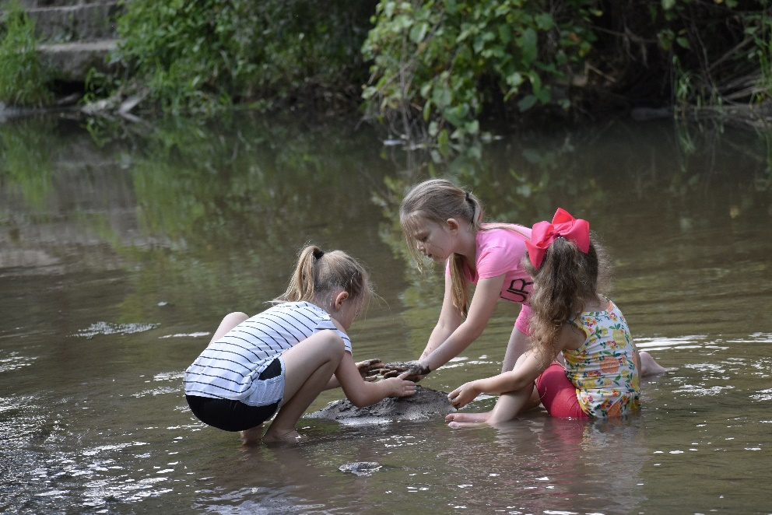

**Discussion Lists**

[Time](http://www.google.com/url?q=http%3A%2F%2Fgroups.yahoo.com%2Fgroup%2FTHEA1999%2F&sa=D&sntz=1&usg=AFQjCNFq0k11IgfF1cyAfjl-s3GDX5Xcow) 4 Learning

Time 4 Learning is an informal collection of homeschooling families that does not exclude on the basis of race, religion, spiritual path, family structure, culture, political view, or academic choice. It is our desire to create a welcoming haven in which families may exchange ideas, share materials, and develop lasting friendships with one another. <https://www.time4learning.com/homeschooling/iowa/local-groups-co-ops.html>

[**Iowa Homeschool Network**](http://www.google.com/url?q=http%3A%2F%2Fgroups.yahoo.com%2Fgroup%2FNCSecularNetwork%2F&sa=D&sntz=1&usg=AFQjCNE3OtOLic0j08AKGQR-gb5e3fU03A) **NICH**

This list is provided as a means to share homeschooling information and to connect with other homeschoolers in Iowa. Spiritual beliefs as well as educational approaches are varied. <https://homeschooliowa.org/>

[**Iowa Homeschool**](http://www.google.com/url?q=http%3A%2F%2Fgroups.yahoo.com%2Fgroup%2FNCarolinahomeschool%2F&sa=D&sntz=1&usg=AFQjCNFvj5fZJ60bZap-n2hvL-Gg3S04dw)

This is a mailing list for people who homeschool or are thinking of homeschooling in the state of Iowa. Here you can exchange ideas, support, share links and more. <https://homeschooliowa.org/iowa-homeschool-numbers-increasing/>

**Leaping from the Box**

Leaping from the Box is a fully moderated, Christian based loop which provides information and encouragement to homeschooling families in the Triangle area and surrounding counties of Iowa. <https://www.leapingfromthebox.com/hs/elists/iowa.html>

[**Network of Iowa Christian Home Educators**](http://www.the-niche.org/)

The purpose of the NICHE is to provide support and information to homeschooling families in the state of Iowa. The members of the NICHE board of directors each sign a statement of faith, but no faith statements are required of the general membership. Has publication: Homeschool Iowa.” Join mail list to subscribe

**Additional Resources**

**Home schooling Stores**

<https://homeschooliowa.org/magazine/2017/summer/files/assets/common/downloads/Summer%202017.pdf>

**Educational Philosophies in the Home School**

I found this information on two different websites. The home schooling styles/educational philosophies are explained a little differently in each one. I couldn't decide which one to choose, so I'm leaving them both here. Good information! Enjoy! JC

<https://www.homeschool-life.com/610/custom/12412>

**Traditional Approach**

This method is a “school-at-home” method of homeschooling. You can read more about the traditional homeschool approach and find resources to traditional homeschool curriculum by visiting <http://homeschool-curriculum.org/homeschooling-programs/>

**Classical Approach**

Children are taught tools of learning known as the Trivium, which is divided into three parts: Grammar Stage: Elementary Age that focuses on reading, writing, spelling, Latin, listening, memorization and observation skills. The goal is developing the framework of knowledge and to acquire basic language arts and math skills. [Classical Conversations](https://www.google.com/url?q=https%3A%2F%2Fwww.classicalconversations.com%2Fclassical%2Fclassical-education&sa=D&sntz=1&usg=AFQjCNG305juYmZLuon7_ZTR6PNsHWKJwA) is a good resource for exploring this homeschooling approach.

**The Unit Study Approach**

Takes a theme or topic and delves into it deeply over a period of time. It integrates some or all subjects into one study around this common theme. Many prepared unit studies are available. Example: Unit study on Birds – language arts would be reading and writing about birds, habitats, food, feathers, etc. Science & Math would be studying the parts and functions and life cycles, Social Studies would be determining migration paths, habitats, ecological impact, Art would be sketching, coloring pictures, identifying, building feeders and birdhouses. You can read more about unit study homeschooling at [Homeschooling In The Woods](http://www.google.com/url?q=http%3A%2F%2Fwww.homeschoolinthewoods.com%2Fwhatisaunitstudy.html&sa=D&sntz=1&usg=AFQjCNEiN_alfzOPk3rvf2Y8UKj6r9c98w).

**The Charlotte Mason Approach**

Based on the writings of Charlotte Mason (late 1800s-early 1900s). She was appalled by modern educators who treated children as containers to be filled with pre-digested information instead of as human beings, and the way they broke knowledge into thousands of isolated bits of information to be fed into that container and their artificial learning experiences. Mason’s approach was to teach basic reading, writing and math skills and expose the children to the best source of knowledge for all other subjects like, nature walks, observing and collecting wildlife, art museums, and reading real books with living ideas. [Simply Charlotte Mason](https://www.google.com/url?q=https%3A%2F%2Fsimplycharlottemason.com%2Fwhat-is-the-charlotte-mason-method%2F&sa=D&sntz=1&usg=AFQjCNEaeXG1H8lhf21dKEAcAIjnqXQGAQ) is an excellent resource for learning about this style.

**The Unschooling Approach**

Less structured learning that allows children to pursue their own interests with parental support and guidance. Children do well in this who are surrounded by a rich environment of books, learning resources, and adults who model a lifestyle of learning and are willing to interact with children. Formal academics are pursued when the need arises. [John Holt The Foundations of Unschooling](https://www.google.com/url?q=https%3A%2F%2Fwww.johnholtgws.com%2Fthe-foundations-of-unschooling%2F&sa=D&sntz=1&usg=AFQjCNFi2vxB3p9sdSUZLEG1bguS8gTolw) is the best resource to begin your journey with unschooling.

**The Eclectic Approach**

Eclectic homeschoolers use a variety of curricula and resources for what seems needed at the moment. They rarely buy a full curricula and use it exactly as is, but tweak it to fit their students’ needs. They are known to build their own curriculum. More homeschoolers probably use this approach than any other. Curriculum for each child may change year to year, and what works for one child may not work for the other children in your family. There are many, many resources for this style of homeschooling, but you can start with the blog [Eclectic Homeschooling: Raising Global Kids](http://www.google.com/url?q=http%3A%2F%2Feclectic-homeschool.com%2F&sa=D&sntz=1&usg=AFQjCNFor9tzQic8mwOWDydzEo8bbrV1DQ).